# BUILD A EMPLOYEE TRAVEL APPROVAL APPLICATION FOR CORPORATE

**1.INTRODUCTION**

**1.1 OVERVIEW**

**Building an employee travel approval application for a corporate involves creating a software tool that enables employees to submit travel requests and get approval from their superiors or travel managers. The application should allow employees to enter their travel itinerary, including the dates, destinations, purpose of travel, and estimated expenses.**

**The application should also provide a workflow for managers to review and approve travel requests, which can include notifications and reminders to ensure timely approvals. Additionally, the application can include features such as expense tracking, travel policy compliance checks, and integration with other corporate systems such as HR and accounting.**

**Overall, the goal of the employee travel approval application is to streamline the travel approval process and ensure that all travel requests are properly documented and approved in accordance with company policy.Building an employee travel approval application for a corporate involves creating a software tool that enables employees to submit travel requests and get approval from their superiors or travel managers. The application should allow employees to enter their travel itinerary, including the dates, destinations, purpose of travel, and estimated expenses.**

* 1. **PURPOSE**

**The purpose of building an employee travel approval application for a corporate organization would be to streamline and automate the process of requesting, approving, and managing employee travel requests. This application could provide a centralized platform where employees can submit travel requests, and managers can review and approve them. It could also integrate with existing systems, such as the company's expense management software, to track and manage travel expenses.**

**Some benefits of such an application could include:**

**Improved efficiency: An automated travel approval process would save time and reduce errors associated with manual processes, such as paper-based forms and email requests.**

**Increased transparency: Both employees and managers would have visibility into the status of travel requests, making it easier to track the approval process and ensure compliance with company policies.**

**Cost savings: By tracking travel expenses and ensuring that only necessary travel is approved, the organization could save money on unnecessary travel expenses.**

**Enhanced compliance: The application could be designed to ensure compliance with company travel policies, reducing the risk of non-compliant travel and associated legal and financial risks.**

**2.PROBLEM DEFINITION & DESIGN THINKING**

**2.1 EMPATHY MAP**



**2.2 IDEATION & BRAINSTORMING MAP**

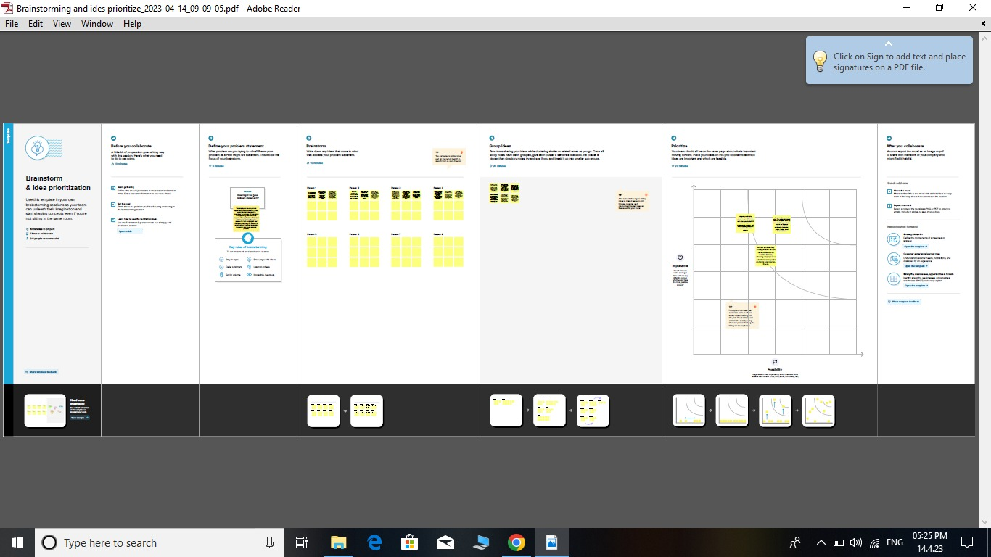

**3.RESULT**

**3.1 DATA MODEL**

|  |  |  |
| --- | --- | --- |
| **Object Name** | **Fields in the Object** | |
|  | Fields | Data Type |
| Travaler | Expense Type | Picklist |
| Department | Trip start date | Date |
| Travel approval | Trip | Currency (18,0) |
| Expense item | Destination state | Geolocation |
|  | Out of state | Geolocation |
|  | Total expenses | Roll up summary |
|  | Travel approval # | Auto Number |
|  | Trip end date | Date |
|  | Travel approval | Master Detail Relationship |

**3.2 Activity & Screenshot**

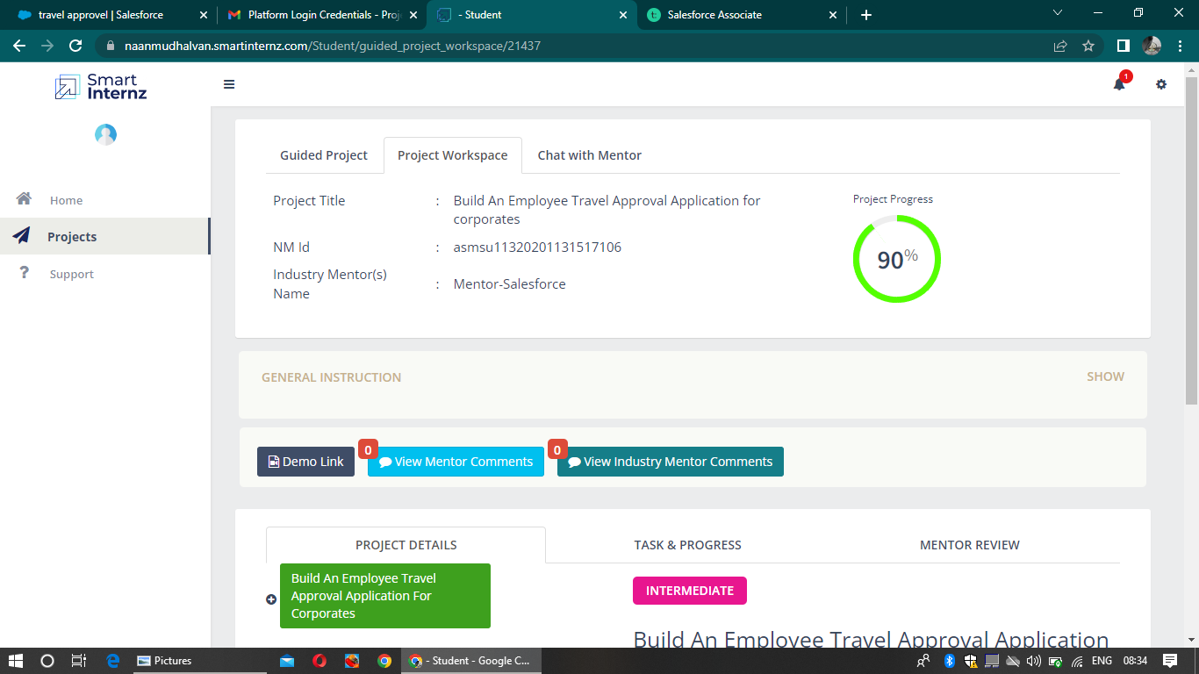

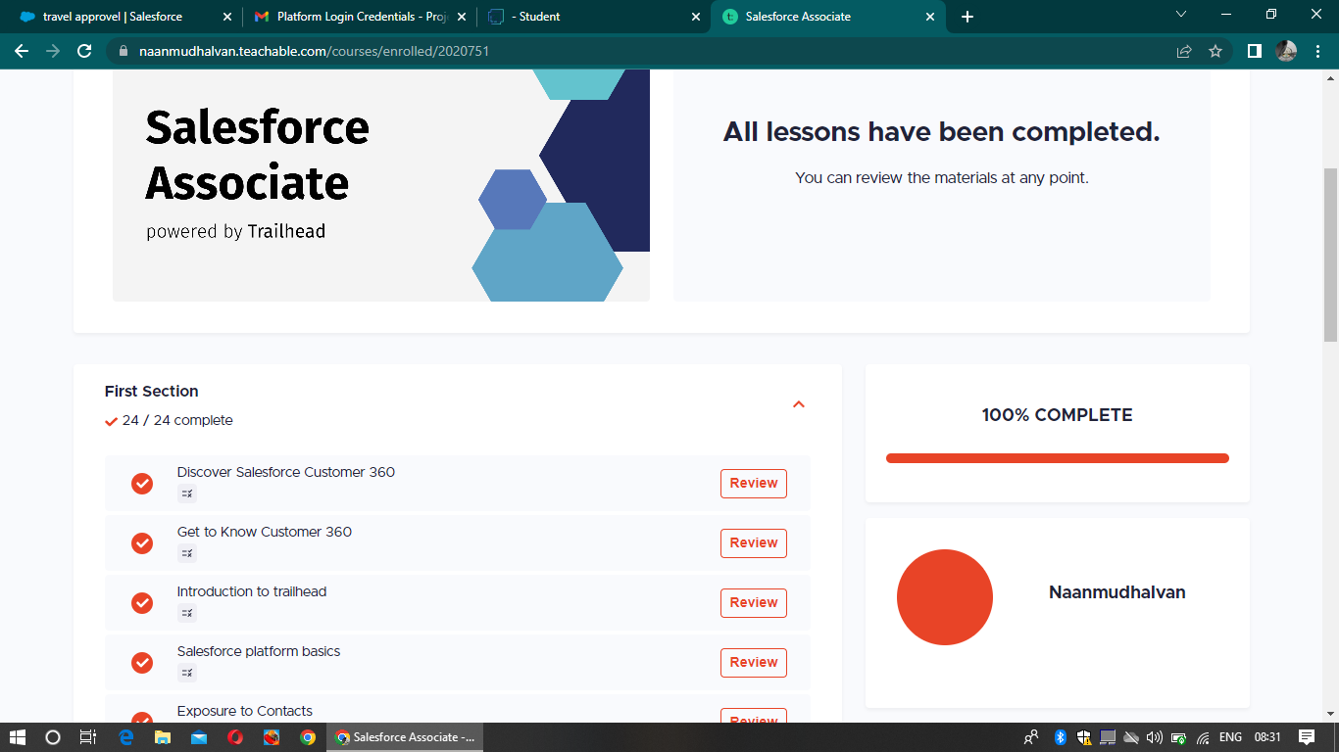

**4.TRAILHEAD PROFILE PUBLIC URL**

**TEAM LEAD -**

**[https://trailblazer.me/id/bagam1](/storage/emulated/0/Android/data/com.yozo.vivo.office/cache/yozoCloud/2023_04_14_16_57_02/trailblazer.me)**

**TEAM MEMBER 1 - [https://trailblazer.me/id/imathi39](/storage/emulated/0/Android/data/com.yozo.vivo.office/cache/yozoCloud/2023_04_14_16_57_02/trailblazer.me)**

**TEAM MEMBER 2 -**

**[https://trailblazer.me/id/spakya](/storage/emulated/0/Android/data/com.yozo.vivo.office/cache/yozoCloud/2023_04_14_16_57_02/trailblazer.me)**

**TEAM MEMBER 3 -**

**[https://trailblazer.me/id/ksamy20](/storage/emulated/0/Android/data/com.yozo.vivo.office/cache/yozoCloud/2023_04_14_16_57_02/trailblazer.me)**

**5.ADVANTAGES & DISADVANTAGE**

**Advantages :**

**Streamline the approval process: An employee travel approval application can help streamline the travel approval process, making it easier and faster for employees to request travel and for managers to approve or deny the request.**

**Time-saving: An application can save time and increase efficiency by automating many of the steps involved in the travel approval process. This includes automated email notifications, automatic calculation of expenses, and generation of reports.**

**Cost-effective: With an employee travel approval application, organizations can reduce the cost of manual travel processing and eliminate the need for paper forms and manual data entry. This, in turn, can lead to cost savings.**

**Data analysis: The application can help organizations analyze travel data, identify patterns, and trends. This information can be used to optimize the travel approval process and make better decisions about travel policies.**

**Disadvantages :**

**Implementation costs: Building an employee travel approval application can be costly, especially if the organization doesn't have the necessary resources or expertise in-house.**

**Maintenance and upgrades: The application requires ongoing maintenance and upgrades to keep it functioning correctly. This can be time-consuming and expensive.**

**Security concerns: Employee travel approval applications handle sensitive information such as employee travel itineraries, personal data, and expense details. Security breaches can put the organization at risk, and securing such an application can be a challenge.**

**User adoption: Employees and managers may be resistant to using a new application, especially if it requires a change in their current travel approval process. User adoption can be a challenge and may require additional training and support.**

**6.APPLICATIONS**

**Building an employee travel approval application for corporate can have many benefits, such as streamlining the travel approval process, reducing administrative work, and providing transparency to both employees and management. Here are some key features and benefits of such an application:**

**Online Travel Requests: An employee travel approval application should allow employees to submit their travel requests online. This feature saves time and eliminates the need for paperwork, emails or other manual methods of submitting travel requests.**

**Automated Approval Workflow: The application should automate the travel approval workflow, allowing managers to approve or reject requests quickly and efficiently. This feature eliminates the need for manual processing of travel requests, reduces the risk of errors, and helps managers make timely decisions.**

**Real-time Status Updates: The application should provide real-time updates on the status of the travel requests. This feature keeps employees informed about the status of their requests, reduces the need for follow-up emails or calls, and provides transparency to the approval process.**

**Integration with Travel Booking Systems: The application should integrate with travel booking systems to simplify the booking process. This feature allows employees to book their travel arrangements directly through the application, reduces the need for manual input of travel information, and provides a seamless end-to-end travel approval and booking process.**

**Expense Reporting: The application should allow employees to submit their travel expenses for reimbursement. This feature streamlines the expense reporting process, eliminates the need for manual entry of expenses, and provides transparency to the reimbursement process.**

**Analytics and Reporting: The application should provide analytics and reporting features to help managers track travel expenses and make informed decisions. This feature provides visibility into travel expenses, helps managers identify trends, and enables them to make data-driven**

**7.CONCLUSION**

**Building an employee travel approval application for a corporate can be a complex and challenging task, but it can also bring many benefits in terms of streamlining the travel approval process and improving communication between employees and managers.**

**To create a successful application, it is important to identify the key requirements and functionalities needed to support the travel approval process, such as requesting approval, submitting travel itineraries, managing expenses, and tracking the status of the request. Additionally, the application should be user-friendly, secure, and scalable to meet the needs of the organization as it grows.**

**Implementing the application will require collaboration with different teams, including IT, HR, and Finance, as well as the involvement of stakeholders such as managers and employees. It will also require testing and debugging to ensure that the application works as intended.**

**Overall, a well-designed employee travel approval application can help the corporate to save time and money, increase efficiency and transparency, and enhance the employee experience.**

**8.FUTURE SCOPE**

**The future scope of building an employee travel approval application for corporates is quite promising, considering the current trends in business travel and digital transformation.**

**Here are some potential areas of growth and development for such an application:**

**Expansion into other industries: While the focus of your application may be on corporate travel, it can be expanded to cater to other industries such as healthcare, education, and government, where employees often need to travel for work-related purposes.**

**Integration with travel and expense management tools: Integrating your application with popular travel and expense management tools such as Concur, Expensify, and TripActions can help streamline the entire travel process for employees, making it more efficient and seamless.**

**AI-powered features: Integrating AI-powered features such as voice assistants, chatbots, and machine learning algorithms can make the application smarter and more intuitive, enabling employees to get personalized recommendations and real-time assistance while planning their travel.**

**Mobile-first approach: With more employees working remotely and on-the-go, a mobile-first approach to your application can be a game-changer. A mobile app that is optimized for smartphones and tablets can make it easier for employees to submit travel requests, track expenses, and stay updated on their travel itineraries.**

**Enhanced security and compliance features: With data security and compliance becoming increasingly important for businesses, your application can include advanced security features such as two-factor authentication, encryption, and secure file sharing to protect sensitive employee and company data**